**Sample Postman output:  
Using basic Auth:**

User name : dinesh

and password: dinesh

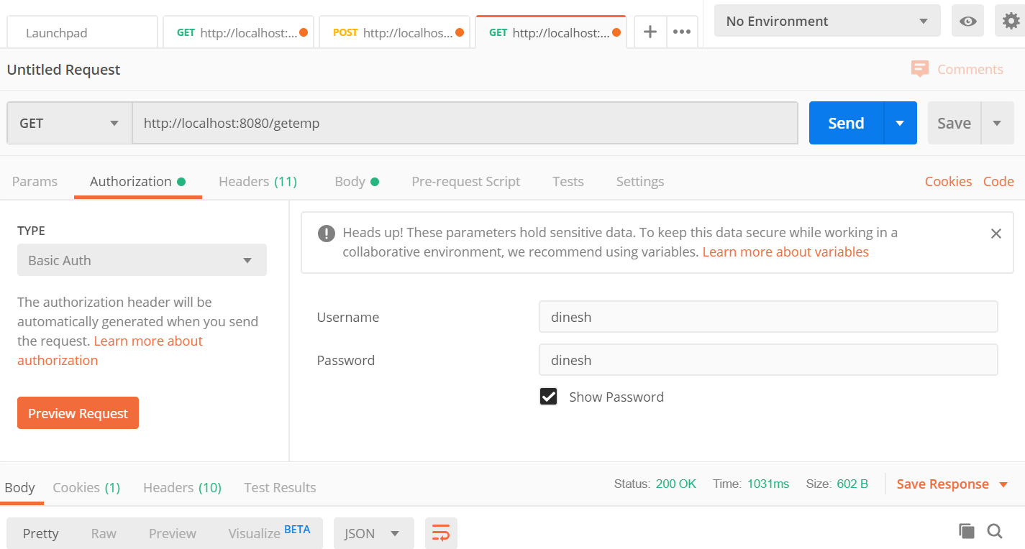

**Add Employee:**

**End Point :** /addEmp **Request Body:**

|  |
| --- |
| {  "name": "Dinesh newly added",  "id": 4,  "company": "trichy Company"  } |

**Response Json:**

|  |
| --- |
| {      "name": "Dinesh newly added",      "id": 4,      "statusCode": 200,      "responseMsg": "Successfully Added"  } |

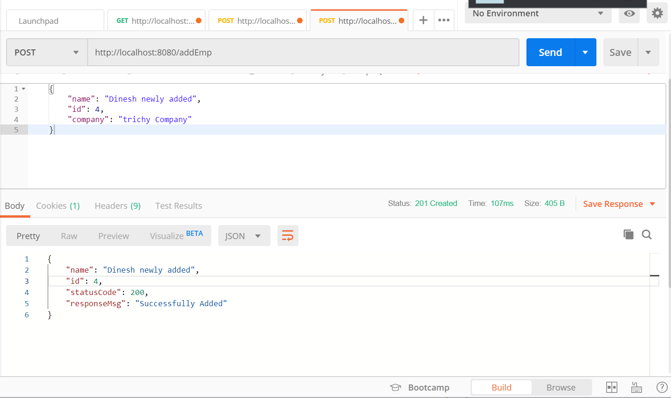

**Get Employee List:  
End point:** /getemp  
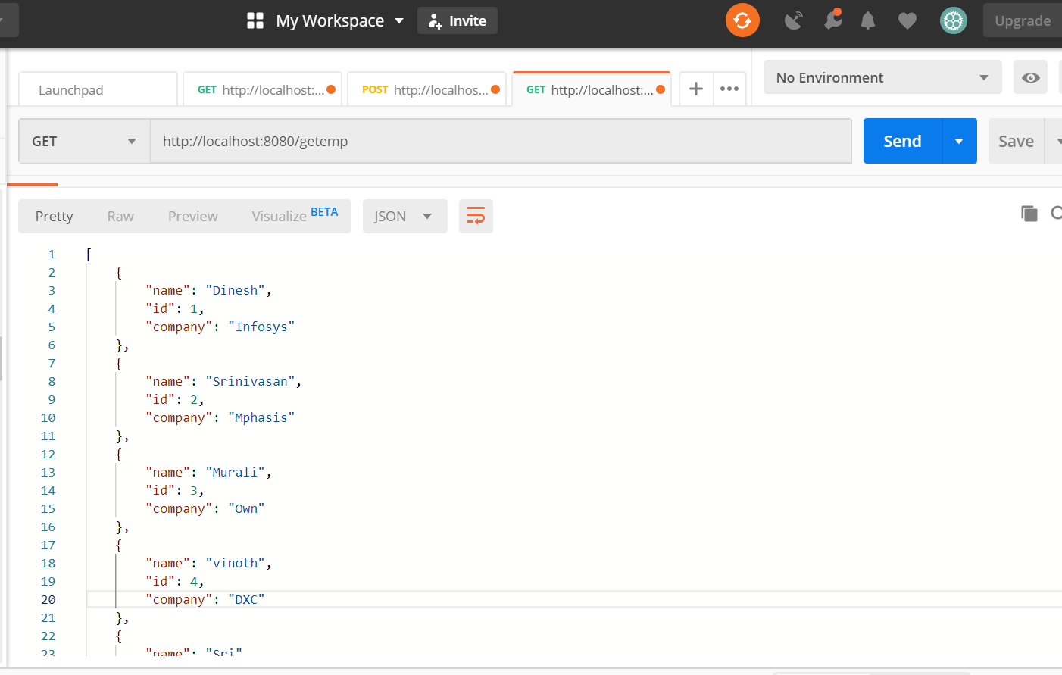

**Get employee by Id:  
  
end point:** /getEmployeeById/{id}

